Collections framework

The **Collection in Java** is a framework that provides an architecture to store and manipulate the group of objects.

Java Collections can achieve all the operations that you perform on a data such as searching, sorting, insertion, manipulation, and deletion.

Java Collection means a single unit of objects

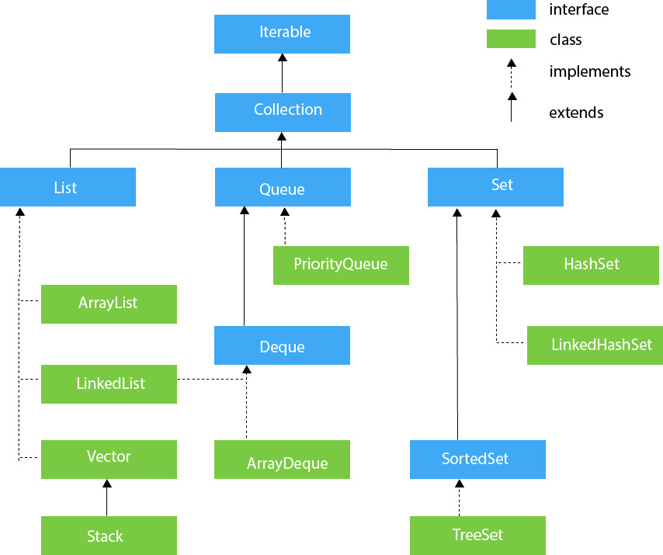

ArrayList: The ArrayList class implements the List interface. It uses a dynamic array to store the duplicate element of different data types.

import java.util.*;

class TestJavaCollection1{

public static void main(String args[]){

ArrayList<String> list=new ArrayList<String>();//Creating arraylist

list.add("Ravi");//Adding object in arraylist

list.add("Vijay");

list.add("Ravi");

list.add("Ajay");

//Traversing list through Iterator

Iterator itr=list.iterator();

while(itr.hasNext()){

System.out.println(itr.next());

}

}

}

creating ArrayList : to create an ArrayList use the Array list class.   
 syntax: ArrayList<String> list=new ArrayList<String>();   
  
 here the arraylist is list(variable , instance of ArrayList class).   
  
 <String> datatype of the objects to be stored in list.  
  
 **adding objects** :

1. .add(objects)